Addressing Provider Burnout and Improving Provider Well-Being: Part I: Diagnosis

Data that have emerged through national surveys, research and consultant reports over the past several years have made it abundantly clear that health care providers are suffering from “burnout” at an alarming rate; up to 50% of physicians in the U.S. experience this malady at some level, a higher prevalence than that in the general population. The contributors to burnout are multifactorial and to some extent result from the rapidly changing environment that is health care today. Research in this arena is in its early evolutionary phase; few studies have shown a positive, sustaining impact.
Definition: emotional exhaustion, de-personalization, decreased effectiveness at work
Contributing factors: EMR, economic pressures, loss of autonomy, increased clerical burdens, debt, increased regulatory mandates, operational inefficiencies, excessive workloads, loss of professional relationships, and work encroachment on personal life
Signs/symptoms: disengagement from work, headaches, irritability, disruptive behavior,
depression, suicidality
Outcomes: moves all 4 BH compass points in the wrong direction: professional dissatisfaction, increased provider turnover, worsening clinical performance, lower quality of care, more medical errors, worsening patient experience

Because provider well-being is foundational to achieving our goals, BMP has chosen to address this head-on. In early 2017, BMP convened a Task Force comprising a professionally-diverse group of physician and advanced practice provider volunteers who delivered to BMP leadership a recommended approach to preventing and mitigating provider burnout at BH. The initial step recommended was to assess its baseline prevalence in our institution. In October 2017 we deployed a nationally validated “well-being” survey to assess the prevalence of “distress” (a validated harbinger of burnout) at Baystate Health. The results of our baseline survey follow here.
Methods:
- The “well-being” survey is an anonymous, web-based tool, developed at Mayo Clinic that evaluates multiple dimensions of distress using just 9 questions. It is designed to measure burnout, provide valuable resources, and allow users and organizations to compare scores to peers and over time to track progress of interventions and promote self-awareness
- We offered the survey over a 4-week period to all 1,700 BH-affiliated physicians (both BMP-employed and independent, community-based physicians). The Medical Staff of BMC generously covered the costs of the system-wide survey. The response rate: 46% among BMP-employed and 13% among non-employed, an overall response rate of 27% (n = 457) which, according to the survey developers, exceeds the national average of response rates
- We only surveyed physicians. Although burnout appears to be increasingly impacting other health care professionals, the tool is only validated for physicians at this time. We did not survey residents, as their issues differ to some extent.
- The deployment of the survey was intended to provide a baseline (i.e. a diagnosis) upon which we could build an intervention plan
Results:
- The mean Distress Score for BH overall is 2.50, higher than the national comparison of 1.73
- 52% of BH physicians had an Index distress score of >3 as compared to 39% nationally
- The “bad news”: the % of physicians at BH with a high level of distress is similar to and slightly higher than the national sample within most career stages
- The “good news”: our early-career physicians (<5 yrs) seem to be in a better state than the national sample; this is an opportunity to intervene and provides hope for a better future

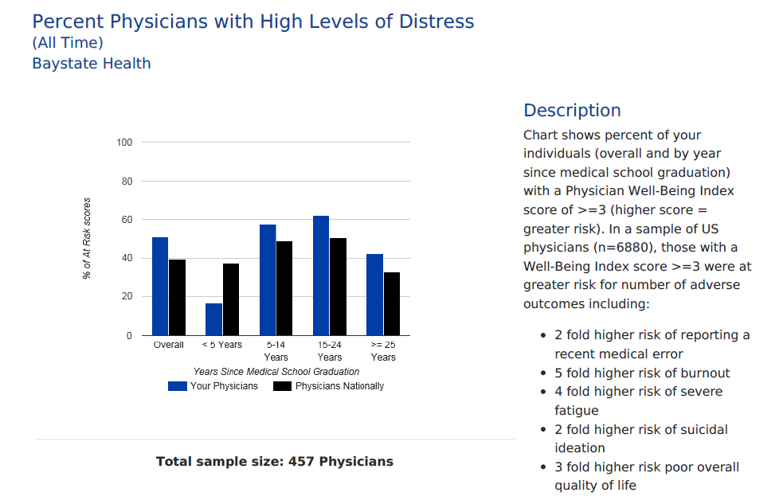
- Our distress index mirrors the pattern of but is slightly higher than national scores for both male and female physicians
- Female physicians tend to have higher distress levels than their male peers—again, this has been shown in multiple studies and surveys but may represent an opportunity and a mandate to intervene for us
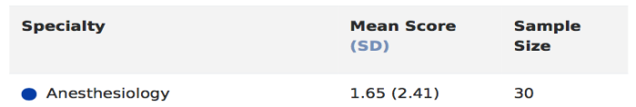
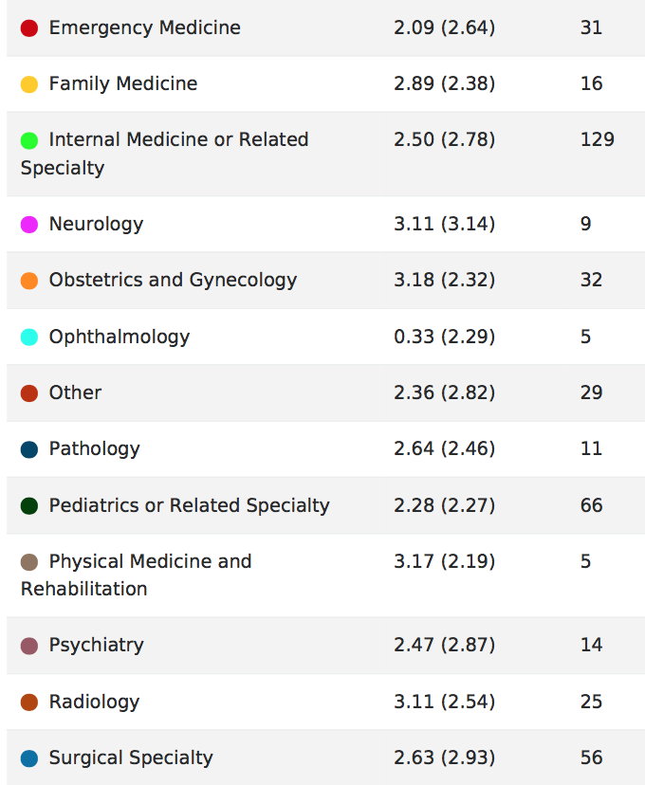
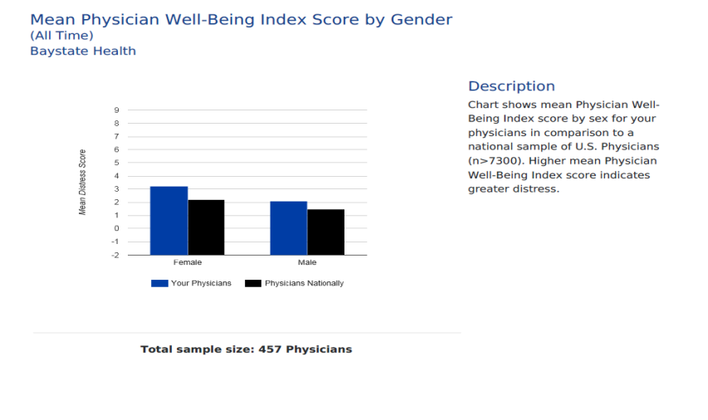
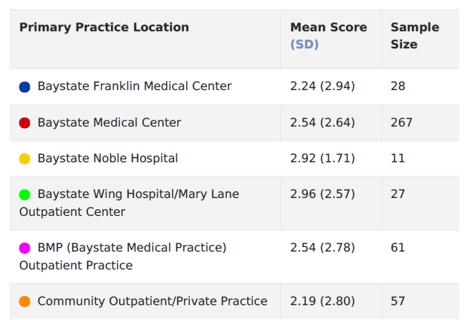
- Our distress index differs somewhat by practice location
- This should inform our diagnostic approach and intervention planning

Distress level is related to specialty, highlighting the importance of unit-specific, customized approaches to deal with this issue
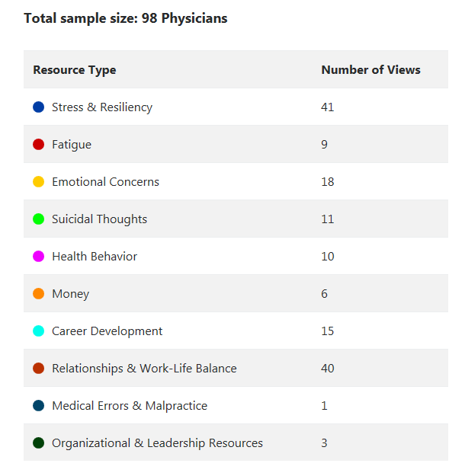
- The Figure to the left represents “Resources accessed by physicians who took the survey”
- 98/457 (21%) of physicians sought resources based on their results; this is higher than expected but a very positive sign that respondents have interest in working to improve their well being
- Of special note and concern is that 11 of our physicians accessed resources re: suicidality
Summary:
- Physicians at BH are experiencing overall high levels of “distress”—which are known to predict burnout—that mirror in pattern but exceed in magnitude that of physicians nationally
- Female physicians have higher levels of distress than their male peers
- While distress levels vary by specialty and practice location, they are elevated and of concern across all domains
- Physicians appear to be invested in improving their well-being
- Education and intervention planning must be somewhat work unit-specific, as different areas have different contributing factors and distinct challenges
Next steps:
- BMP has chartered the Provider Wellness Advisory Committee, co-chaired by Barry Sarvet M.D. and Rob Smith M.D. and comprising nearly 30 BMP- and community physician members; they have started their work on helping to oversee the approach to improving provider well-being at BH
- Their approach will be modeled after the Mayo clinic approach which has proven successful in that organization
- Interventions will be directed towards developing a comprehensive, evidence-based approach to preventing and mitigating provider burnout and enhancing provider well-being, both seen as essential to the long-term clinical- and financial success of BH
- Key strategic goals will be to a) create a culture of provider wellness; b) improve practice/systems efficiency; c) promote personal resilience
- The Advisory team will be fanning out to galvanize this process in the coming months

