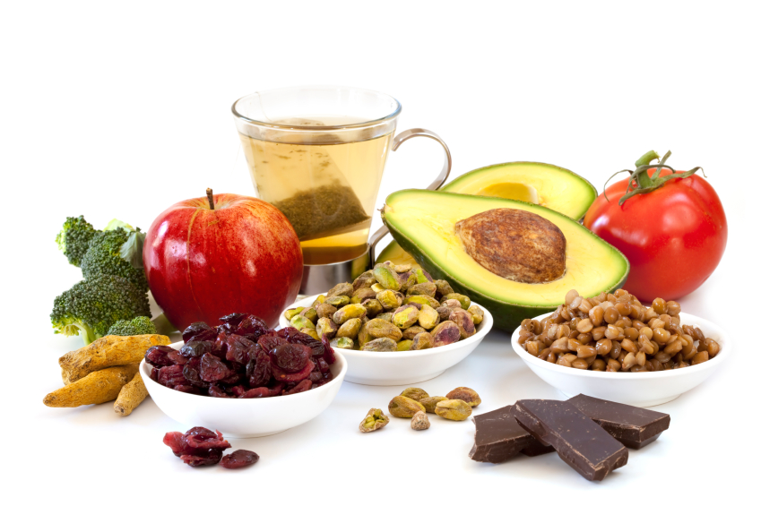
2018 Baystate Healthy Food Tracker

How to use the online* tracker:
- Save this document to a location on your computer where you will be able to easily retrieve it over the course of the 4 weeks. (i.e: your desktop). Go to the toolbar at the top of the page and select “File” “Save As”.
- Click into each fillable field to select the date, enter your exercise type and duration for each day of the week that you completed at least 30 minutes of physical activity.
- Complete the pledge form at the bottom of the page and email this document to BaystateHealthy@baystatehealth.org . Go to “File” “Save & Send” “Send as Attachment”. Please do not send a PDF version or screenshot.
* This tracker is designed to be completed online, however if you need to print it, the document is formatted to print on 11x17 paper. Select “File” “Print” and interoffice mail completed tracker to Baystate Healthy, 280 Chestnut St. Springfield, MA

Eat for Energy!
Sustain your energy and stamina throughout the day with these simple ideas.
Balance your food and calories through the day.
-Eat 3 meals and 2-3 snacks each day.
-Never go longer than 4 hours without eating.
-Eat breakfast every day and within 1 hour of waking up.
Balance your plate.
-50% of the plate = vegetable and fruit
-25% of the plate = protein
-25% of the plate = breads/grains/cereals/starches
Watch your portion sizes.
-Eat only enough to fuel your body over the next 2-3 hours.
-Eat slowly and only eat until you feel satisfied.
-Overeating leads to excess glucose, insulin and fat storage and decreases your energy level.
Follow the 80/20 rule.
The 80/20 Rule for eating is a realistic approach to a healthy, balanced food intake. You can think of the 80/20 Rule in a variety of ways:
-Eat healthy 80% of the time.
-Stop eating when your stomach is 80% full.
-To lose weight, eat only 80% of your usual caloric intake, in other words, dish out 20% less on your plate.

Make Healthy Eating a Habit
Using a food tracker creates a conscious awareness of your food intake and eating patterns. Many people find that using a Food Tracker is a helpful tool in losing weight.

- Each day, record all food, drink and the amount consumed.
- Aim to eat at least 2-4 cups of vegetables and 1½-2½ cups of fruit each day.
- Track 4 consecutive weeks of intake.
- Continue to use the tracker until you create a habit.

Week 1
 | Date | Breakfast | Lunch | Dinner | Between Meals
Sunday | Date | What did you have for breakfast today? | What did you have for lunch today? | What did you have for dinner today? | What else did you eat today?
Monday | Date | What did you have for breakfast today? | What did you have for lunch today? | What did you have for dinner today? | What else did you eat today?
Tuesday | Date | What did you have for breakfast today? | What did you have for lunch today? | What did you have for dinner today? | What else did you eat today?
Wednesday | Date | What did you have for breakfast today? | What did you have for lunch today? | What did you have for dinner today? | What else did you eat today?
Thursday | Date | What did you have for breakfast today? | What did you have for lunch today? | What did you have for dinner today? | What else did you eat today?
Friday | Date | What did you have for breakfast today? | What did you have for lunch today? | What did you have for dinner today? | What else did you eat today?
Saturday | Date | What did you have for breakfast today? | What did you have for lunch today? | What did you have for dinner today? | What else did you eat today?
Week 2
 | Date | Breakfast | Lunch | Dinner | Snacks
Sunday | Date | What did you have for breakfast today? | What did you have for lunch today? | What did you have for dinner today? | What else did you eat today?
Monday | Date | What did you have for breakfast today? | What did you have for lunch today? | What did you have for dinner today? | What else did you eat today?
Tuesday | Date | What did you have for breakfast today? | What did you have for lunch today? | What did you have for dinner today? | What else did you eat today?
Wednesday | Date | What did you have for breakfast today? | What did you have for lunch today? | What did you have for dinner today? | What else did you eat today?
Thursday | Date | What did you have for breakfast today? | What did you have for lunch today? | What did you have for dinner today? | What else did you eat today?
Friday | Date | What did you have for breakfast today? | What did you have for lunch today? | What did you have for dinner today? | What else did you eat today?
Saturday | Date | What did you have for breakfast today? | What did you have for lunch today? | What did you have for dinner today? | What else did you eat today?
Week 3
 | Date | Breakfast | Lunch | Dinner | Snacks
Sunday | Date | What did you have for breakfast today? | What did you have for lunch today? | What did you have for dinner today? | What else did you eat today?
Monday | Date | What did you have for breakfast today? | What did you have for lunch today? | What did you have for dinner today? | What else did you eat today?
Tuesday | Date | What did you have for breakfast today? | What did you have for lunch today? | What did you have for dinner today? | What else did you eat today?
Wednesday | Date | What did you have for breakfast today? | What did you have for lunch today? | What did you have for dinner today? | What else did you eat today?
Thursday | Date | What did you have for breakfast today? | What did you have for lunch today? | What did you have for dinner today? | What else did you eat today?
Friday | Date | What did you have for breakfast today? | What did you have for lunch today? | What did you have for dinner today? | What else did you eat today?
Saturday | Date | What did you have for breakfast today? | What did you have for lunch today? | What did you have for dinner today? | What else did you eat today?
Week 4
 | Date | Breakfast | Lunch | Dinner | Snacks
Sunday | Date | What did you have for breakfast today? | What did you have for lunch today? | What did you have for dinner today? | What else did you eat today?
Monday | Date | What did you have for breakfast today? | What did you have for lunch today? | What did you have for dinner today? | What else did you eat today?
Tuesday | Date | What did you have for breakfast today? | What did you have for lunch today? | What did you have for dinner today? | What else did you eat today?
Wednesday | Date | What did you have for breakfast today? | What did you have for lunch today? | What did you have for dinner today? | What else did you eat today?
Thursday | Date | What did you have for breakfast today? | What did you have for lunch today? | What did you have for dinner today? | What else did you eat today?
Friday | Date | What did you have for breakfast today? | What did you have for lunch today? | What did you have for dinner today? | What else did you eat today?
Saturday | Date | What did you have for breakfast today? | What did you have for lunch today? | What did you have for dinner today? | What else did you eat today?
If you are participating in MyHealth Rewards track 4 consecutive weeks of food intake to qualify. Read, complete and sign the pledge below. Submissions must be received by October 15, 2018. You can submit four Food Trackers to earn up to $100 during the 2018 program year. For complete program rules go to eWorkplace/Baystate Healthy/MyHealth Rewards

Congratulations!

You’ve kept yourself on track for 4 weeks! We encourage you to continue to make healthy eating a part of your life.

If you are participating in MyHealth Rewards, please read the pledge statement and then fill in the form below.
I pledge that I have completed this Food Tracker as accurately as possible. I understand that my food tracker may be audited.

First Name: Last Name: EN # (without “EN”): Date: Phone:
Food2018

Submit this Fitness Tracker by email to BaystateHealthy@baystatehealth.org by October 15, 2018

Health, Wellness and Worklife Solutions: 413-794-4939

