Mountain View Farm CSA
A Community Support Agriculture (CSA) Farm Serving Western Massachusetts and New York City
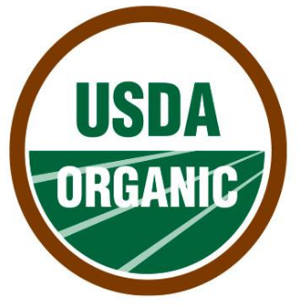

2019 – 2020 Winter Share

Shareholder Agreement Form
First Name: | Date:
Last Name: | Employee ID Number:
Email: | Phone:

Program Information:
- The cost of a Winter Share for 2019 -2020 season is $280. That is about $1.80 per pound for organic, washed and stored produce all winter long!
- Each pick-up will consist of approximately 25 pounds of produce including carrots, winter squash, beets, sweet potatoes, purple top turnips, kale, watermelon radishes, daikon, red potatoes, yellow potatoes, white potatoes, hakurei turnips, garlic, winter greens, kolhrabi, onions and more.
- Pick-Up Location: Mountain View Farm, 393 East Street, Easthampton MA. The pick-up date and time is Saturday from 9AM – 5PM on the following dates: November 16 and 30, December 14 and 28, January 11 and 25. Phone: 413-329-0211 ● E-mail: info@mountainviewfarmcsa.com ● Website: www.mountainviewfarmcsa.com

As a member I understand:
- This is a Community Supported Agricultural (CSA) venture and that, although the farmer is committed to providing high quality produce, there are risks in agriculture that need to be shared by the whole community.
- As a member of the community, I am purchasing a “share” of the farm’s annual harvest in advance of the growing season. All payments are nonrefundable.
- If I elect to pay through Baystate payroll, I must submit my Payroll deduction form by November 1, 2019 in order to pick up my first share.
- The pick-up dates may have to change due to inclement weather.
- It is my responsibility to pick up my share at Mountain View Farm on the specified days and times.

Payment Information:

I opt for payment through payroll deduction. $56 for 5 consecutive pay periods will be deducted. Complete payroll deduction form on next page. Deductions will begin in October.

I opt for payment through personal check. Send full payment to Baystate Healthy, 280 Chestnut St., Springfield, MA 01199 made payable to Baystate Health.

To enroll:
Email your completed shareholder agreement form to: Baystatehealthy@baystatehealth.org. If you are unable to send the form electronically, a completed application can be mailed to: Health, Wellness & WorkLife Solutions; 280 Chestnut Street, 5th floor, Springfield, MA 01199. The agreement form and payment arrangements must be received in our office by November 1, 2019. Please keep a copy for your records. For questions, call 413-784-4939.

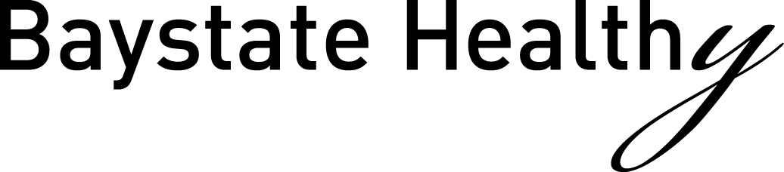

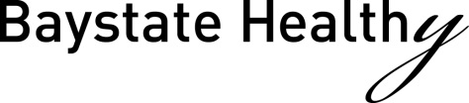

Health, Wellness & WorkLife Solutions
413-794-4939
Division of Human Resources
Payroll Deduction Form

_______________________
Date

_________________________________________________________________
Name

_________________________________________________________________
Employee ID #

_________________________________________________________________
Cost Center/Department

_________________________________________________________________
Telephone/Extension

Mountain View Farm Winter Share 2019-2020- $280 ($56.00 x 5 pay periods)

I understand that I am agreeing to a deduction from my paycheck. Deductions will begin in October.

_________________________________________________________________
Signature

_________________________________________________________________
Please Print

Keep a copy for your records.

