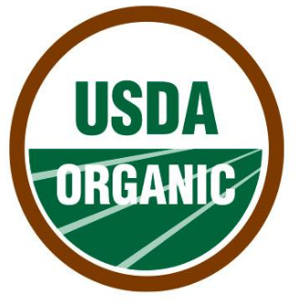

2018 – 2019 Winter Share

Shareholder Agreement Form
First Name: | Date:
Last Name: | Employee ID Number:
Email: | Phone:

The cost of a Winter Share for 2018–2019 season is $275. That is about $1.50 per pound for organic, washed and stored produce all winter long!

Pick Up Dates and Times: Saturdays from 9am to 5pm
November 17
December 1, 15 and 29
January 12 and 26

Payment Information:

I opt for payment through payroll deduction. $55 for 5 consecutive pay periods will be deducted. Complete payroll deduction form on next page.

I opt for payment through personal check. Send full payment to Baystate Healthy, 280 Chestnut St., Springfield, MA 01199 made payable to Baystate Health.

As a member I understand:
- Each pick up will consist of approximately 25 pounds of produce including carrots, beets, sweet potatoes, cabbage, purple top turnips, black radishes, kale, watermelon radishes, daikon, leeks, potatoes, Hakurei turnips, garlic, onions, and more.
- I must submit my Payroll deduction form by November 2, 2018 in order to pick up my first share.
- The pick-up dates may have to change due to inclement weather.
- This is a Community Supported Agricultural venture and that, although the farmer is committed to the best of his ability to provide high quality produce, there are risks in agriculture that need to be shared by the whole community.
- It is my responsibility to pick up my share at Mountain View Farm on the specified days and times and payments are non-refundable.

To enroll: Email your completed shareholder agreement form to: Baystatehealthy@baystatehealth.org.
If you are unable to send the form electronically, a completed application can be sent to: Health, Wellness & WorkLife Solutions; 280 Chestnut Street, 5th floor, Springfield, MA 01199. The agreement form and payment arrangements must be received in our office by November 2, 2018. Please keep a copy for your records.

Mountain View Farm: The farm is located at 393 East Street, Easthampton, MA 01027.
Phone: 413-329-0211. E-mail: info@mountainviewfarmcsa.com.
Website: www.mountainviewfarmcsa.com
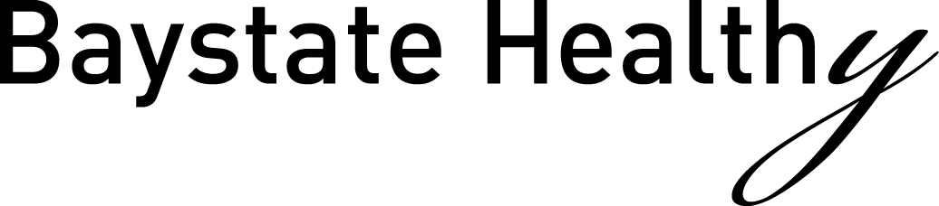

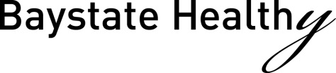
Health, Wellness & WorkLife Solutions
413-794-4939
Division of Human Resources
Payroll Deduction Form

_______________________
Date

_________________________________________________________________
Name

_________________________________________________________________
Employee ID #

_________________________________________________________________
Cost Center/Department

_________________________________________________________________
Telephone/Extension

Mountain View Farm Winter Share 2018-2019- $275 ($55.00 x 5 pay periods)

I understand that I am agreeing to a deduction from my paycheck. It will be indicated as a deduction for Wellness-Work-Life Event.

_________________________________________________________________
Signature

_________________________________________________________________
Please Print

Keep a copy for your records.

